

FUNDAMENTAL OF COMPUTER PROGRAMMING

LAB_5



October 20, 2024

HANAN MAJEED

CMS ID: 519166

BSDS-2-A

**Task A:**

Using While loops, generate the following output: 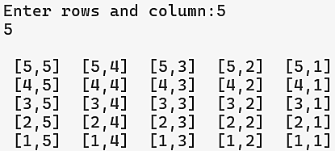

INPUT:

OUTPUT:

**Task B:**

The factorial of an integer N, written N! is simply the product of all the integers from 1 to n. For example, 5! = 1*2*3*4*5 = 120.

Write a program to calculate the factorial of an integer N entered by the user. Make sure that the user enters a number greater than 0, otherwise, an appropriate error message is shown, and the input is asked again.

INPUT:

OUTPUT:

**Task C:**

Write a program that generates the following output using For loops.

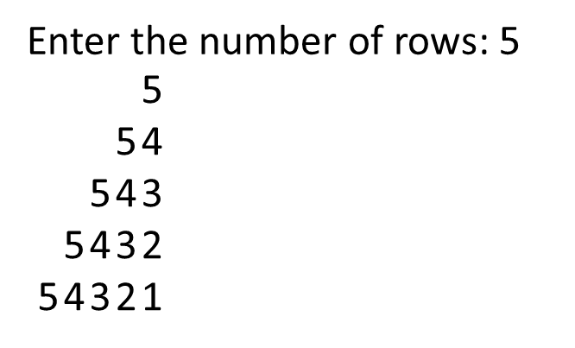

INPUT:

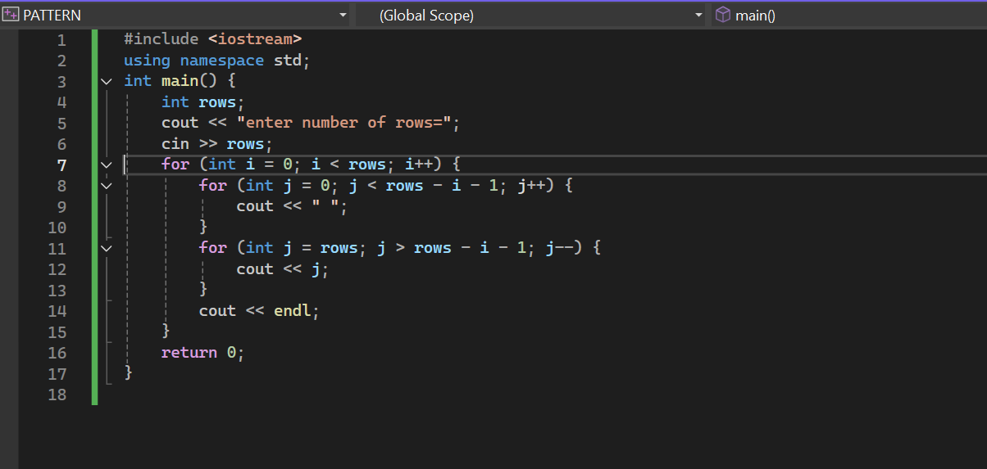

OUTPUT:

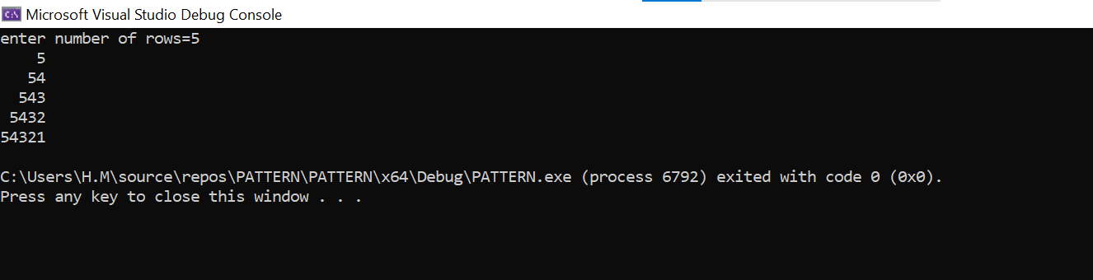

**Task D:**

A palindrome is a number or a text phrase that reads the same backward as forward. For example, each of the following integers is palindrome: 12321, 5555555, 6455546, and 161. Write a program that gets an integer from the user and determines whether or not it is a palindrome.

INPUT:

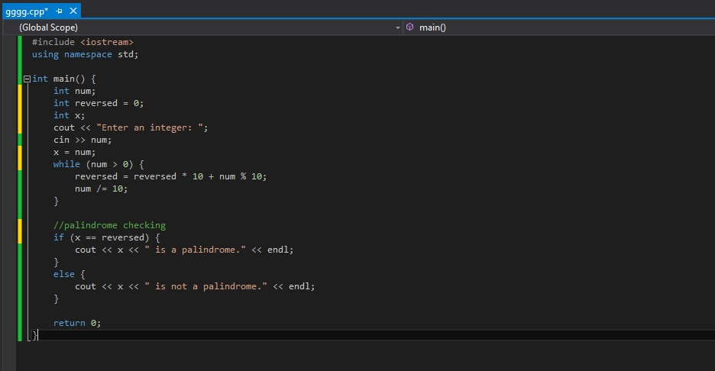

OUTPUT:

**Task E:**

Write a program that prompts the user to guess a number between 1 to 10. After each incorrect guess, give a hint to the user if the actual number is greater or lower than the guessed number. The user will try to guess the secret number until they get it right. Count the number of tries it takes the user to guess it and show it to the user at the end. A sample output is given below: A close up of text

INPUT:

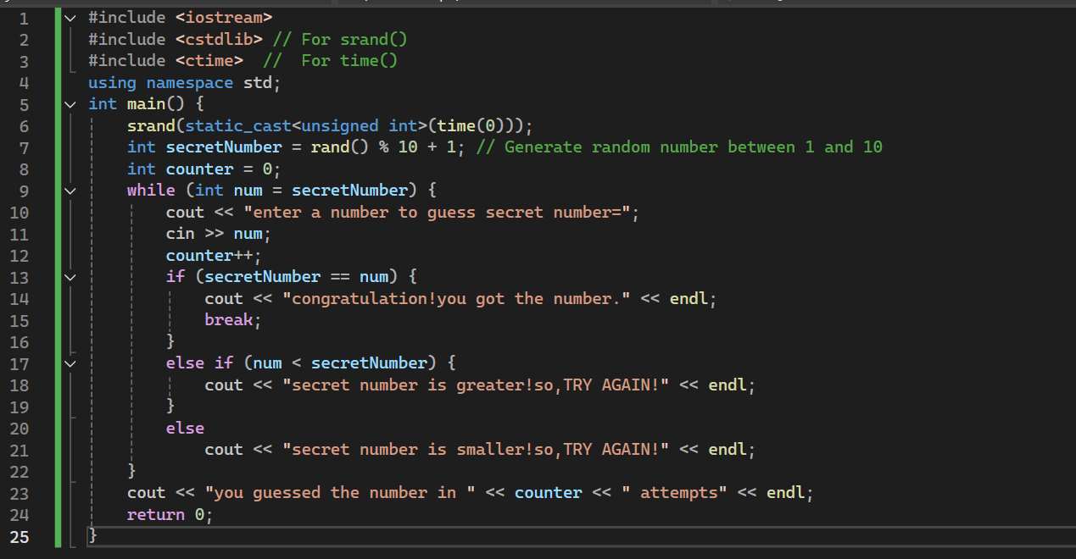

OUTPUT: